- Prove 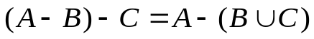.
2. There are ten young men of which 5 persons are workers, 7 persons are students and 3 persons are both workers and students. Question: How many persons are neither workers nor students? Please use set theory to present your answer.
3. is the set of real number. For 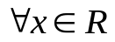, 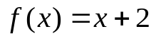, 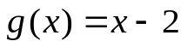 and 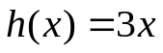. What is 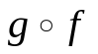 and 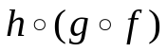?
- A={ 1，2，3 }，B={ a，b，c }，C={ x，y，z }.
R：A→B，S：B→C，and R={ <1，b>，<2，a >，<2，c> }, S={< a，y>，<b，x> ，<c，y>，<c，z>}，R о S = __________ .
5. Suppose A={1,2,3,4,5,6},B={2,4,6},C={x|x=n³,n∈N,x<15}, then B-A = ________，A∪C = _____
6. ( A – B ) – C = ( ) Why?
A. ( A – C )– ( B – C ) B. A – ( B – C ) C. A - A∩B - A∩C D. A – B – C
7. Function  is defined as 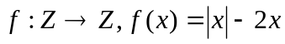, so is ( )
A. onto B. one-to-one C. both onto and one-to-one D. neither onto nor one-to-one
Why?

